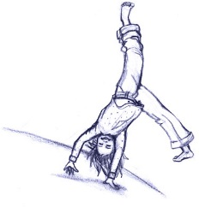
Term 1 Sept 5th – Jan 28th 2017 Term 2 Jan 30th- June 24th 2017
New! 5month terms! & Monthly payment options
*Tuition is payable upon registration.*All students must pay a $35 registration fee
Whitby Supernova Gymnastics
Dream Believe Achieve
Programs | Mon  Hands Up Gym & Sport Zone - Preschool and kindergym! Come check it out! Little hands and little feet are a perfect fit in the H.U.G.S. Zone. | Tues | Wed | Thurs | Fri | Sat | Sun
Hands Up Gym and Sport Zone - Preschool and Kindergym program
Holding Hands 18mths-3 years  45mins class  $45/mth or $225/term | 5:00-5:45 | 10:00-10:45 | 10:15-11:00 |  |  | 10:15-11:00
Little Handsup – 3+ 4 year olds  1hr. Class  $55/mth or $275/term. | 6:00-7:00 | 10:00-11:00  5:00-6:00  6:00-7:00 | 10:15-11:15  4:30-5:30  6:00-7:00 | 5:00-6:00  6:00-7:00 |  | 10:00-11:00  11:00-12:00
Hands up Kids 5 year olds.  1 hour class  Now $55/mth or $275/term. | 5:00-6:00  6:00-7:00 | 10:00-11:00  5:00-6:00  6:00-7:00 | 10:15-11:15  4:30-5:30  6:00-7:00 | 5:00-6:00  6:00-7:00 |  | 10:00-11:00  11:00-12:00
SuperKids – Adv3-5yrs 1.5hr.  $75/month or $375/term INVITE |  |  |  | 6:00-7:30
NovaGym Recreational Programs
Our recreational program follow Gymnastic Canada`s Progressive CanGym award and badge program. 14 progressive levels to achieve!
NovaGym 1 Girls Rec  6-8 year olds 1.5hr. class  $75/month or $375/term | 6:00-7:30  7:00-8:30 | 5:30-7:00  7:00-8:30 | 5:30-7:00  7:00-8:30 | 6:00-7:30 | 4:45-6:15 | 10:30-12:00  12:00-1:30
NovaGym 2 Girls Rec.  9-11 year olds 1.5hr. class  $75/month or $375/term | 6:00-7:30  7:00-8:30 | 5:30-7:00  7:00-8:30 | 5:30-7:00  7:00-8:30 | 6:00-7:30 | 4:45-6:15 | 10:30-12:00
NovaFlex (Boys) 5-8 years  1.5hr. class  $75/month or $375/term | 6:00-7:30
NovaFlex(Boys) – Ages 9+  $75/month or $375/term |  |  |  | 6:00-7:30
Tumbling – 7-12yrs. 1hr. 15min  $67/month $335/term |  |  |  |  | 6:30-7:45
Advanced Recreation 7+  $90/Month $450 term 2 hr. class |  |  | 7:00-9:00
Nova Teens  $75/month or $375/term 1.5HR. class | 7:30-9:00 |  | 7:00-8:30
CanCompete – Invite Only | 6:00-8:00 |  | 6:00-8:00
Mini Competitive – invite only  4-6yrs | 4:30-6:30 |  | 4:30-6:30
 |  |  |  |  |  | 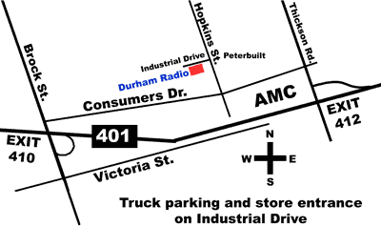
Fall classes begin on Jan 30th 2016. Registration is easy; call, email or drop in or register ONLINE!
We are a year round gymnastics club! Enroll anytime! Pay by the month or by the term.
Whitby Supernova Gymnastics
111 Industrial Dr, Whitby, Ont., L1N2C3
289-600-3185
www.supernovagymnastics.com supernovagymnastics@gmail.com
Supernova
*Recreational
*Competitive
*Birthdays
*Teens
*Summer Camp
* Trampoline

